 | Monday | Tuesday | Wednesday | Thursday | Friday | Saturday | Sunday

What did you do in the daytime?

Did you drink tea/ coffee/ coke or energy drinks?
How many?


Did you have any naps during the day?
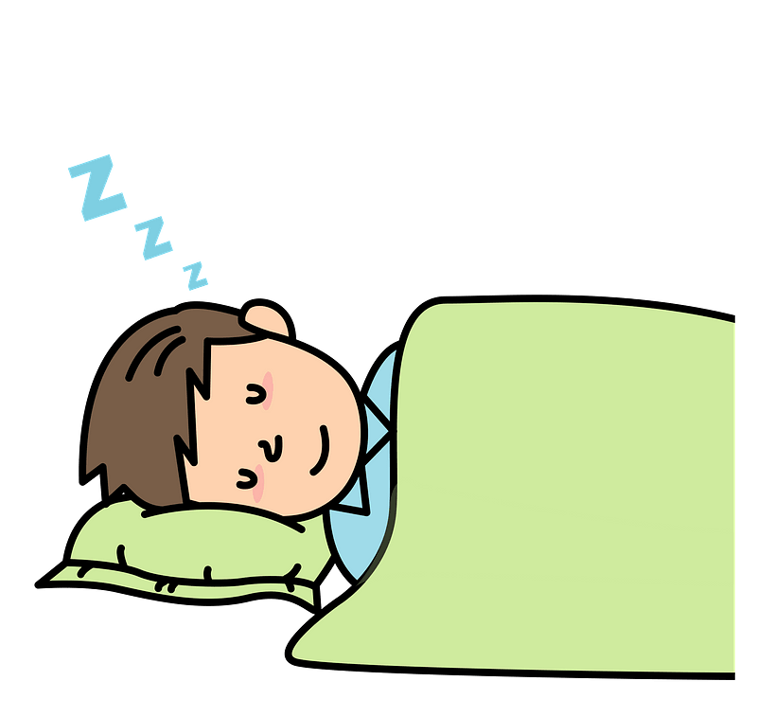
What did you do before going to sleep?
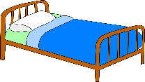
What time did you go to bed?
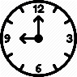
How many hours did you sleep?

How many times in the night did you wake up?


My Sleep Diary

